Report on Students’ English Literary Association
Organised by the Department of English
2021-2022

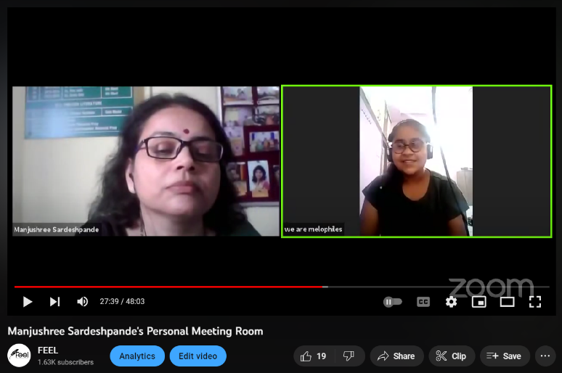
The English department organises a program for advance learners of English. The department has formed a Students’ English Literary Association (SELA) wherein the students are taught creative writing. Well known creative writers are invited as resource persons to guide the students in writing poems, articles, stories, blogs, news-reports etc. the students’ articles are published in newspapers and in the college magazine Prerna. This year the Students’ English Literary Association was inaugurated on 14 October 2021. Dr. Sujata Chakravorty, Associate Professor in English, Dayanand Arya Kanya Mahavidyala, Nagpur, was invited as the Chief Guest. She guided the students, throwing insight on how they could explore their potential in creative writing. Around 11 students- Shubham Waghmare, Hetvi Patel, Anchal Khankure, Janhavi Wanjari, Kunal Meshram, Muskan Ranglani, Vishal Wankhede, Lokesh Deshmukh, Aishwarya Shende, Hrutuja Manbekar and Aditi Bawiskar presented their creative writing. Following office bearers were elected on that day: Ms. Hetvi Patel as President, Mr. Shubham Waghmare as Vice-president, Ms. Janhavi Wanjari as Secretary. 125 students became members of SELA. The program was conducted online and also streamed live on YouTube. Students from all the disciplines attended the program in large number.
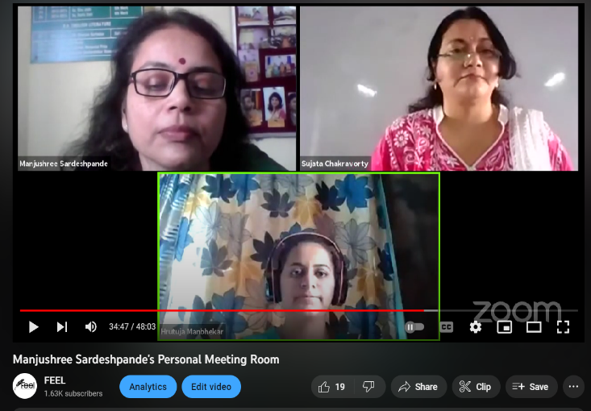
YouTube link: https://youtu.be/hhtOSKQ5frI

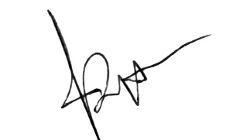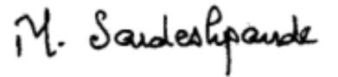
Dr. Tanuja Nafde Dr. Manjushree Sardeshpande
Principal Convener

