Report on Students’ English Literary Association
Organised by the Department of English
2018-19

For the lovers of creative writing and literature a Students’ English Literary Association (SELA) is in place and every year new office bearers are appointed. Interested students from B.A, B.Com, B.B.A, B.C.C.A, are all members of this association. This year the inauguration of SELA was held on 1 October 2018. The new office bearers appointed were Arvind Baghele from BCCA-I year as President Kalyani Gadre from BBA-II year as Vice- President, Nidhi Ingole from B. Com-II as Secretary, Chaitanya Dube from B.A-I year as Joint-Secretary, Priyanka Mohalle from B.Com-III as Treasurer. Dr. Prantik Banerjee from Hislop College, Nagpur was invited as the Chief Guest to deliver a lecture on creative writing. On the occasion, Dr. Manjushree Sardeshpande, Head of the Department gave the introductory speech informing about the activities of the Students’ Literary Association, Mr. Umesh introduced the Chief Guest, students members of SELA, Ms. Pratiksha Warghat of B.A-I year, Ms. Khushboo Bhagchandani of B.A-II year, Ms. Kalyani Gadre of BBA-II year and Ms. Nidhi Ingole of B.Com-II year presented their creative compositions. The writings of Kajal Mishra, Kanchan Shendre, Pragya Rathore, Sudhir Tailasi, Seema Ratanwar, Anuj Sharan, Jagruti Nagre, Anchal datir, Sanket Shahare were published in the college magazine Prerna. Dr, Sandhya Nair, Principal of the college presided over. Bhagyalakshmi Atrye from B.Com final year conducted the programme. Sagir Sheikh proposed a vote of thanks.
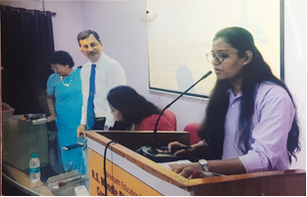
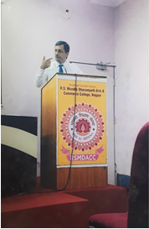

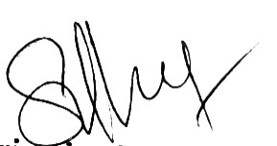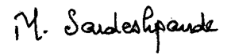

Dr. Sandhya Nair  Principal | Dr. Manjushree Sardeshpande  Convener

