Report on Students’ English Literary Association
Organised by the Department of English
2017- 2018

Students’ English Literary Association was formed and the inauguration of SELA was held on 29 September 2017. The elected office bearers were as follows: Ms. Sonal Chouhan as President, Ms. Nidhi Ingole as Vice-President, Sagir Sheikh as Secretary. Dr. Pravin Joshi, Vice-Principal of Sindhu Mahavidyalaya was invited as the Chief Guest. He also delivered a lecture on Creative Writing.
The students of SELA published their creative writings in the Youth Zone of Hitavada. Following students published their poems: 1) Ms. Zehra Khwaja’s poem Cycle, 2) Ms. Khushboo Bhagchandani’s poems Suicide and Woman, 3) Nidhi Ingole’s article Maybe They Were Wrong, 4) Peenaz Mawalvala’s write up on Macbeth. Their creative writing was appreciated by a scientist Mr. Sutavne who gave them prizes. The creative writings of Bhagyalaxmi Atrey, Chinmay Joshi, Shital Pangul, Aishwarya Thakre, Kalyanti Gadre, Sakshi Nagose, Bhavi Deshmukh, Apurva Khode and Trishna Bhange were published in the college magazine Prerna.

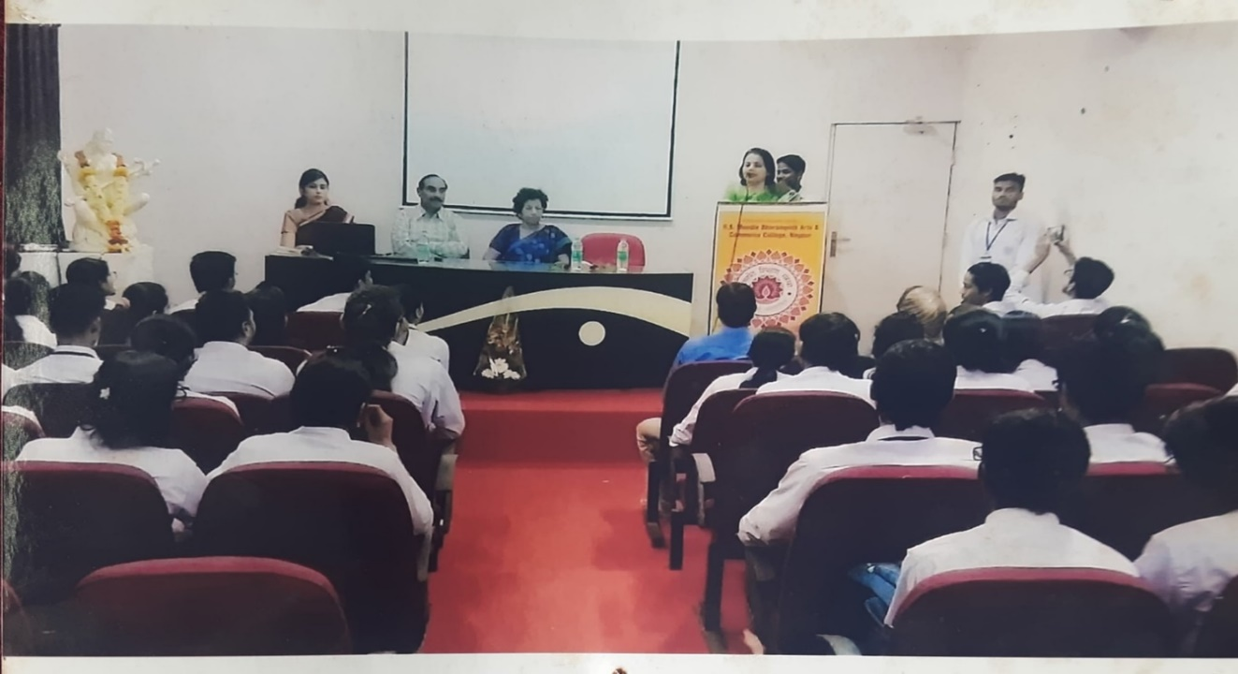
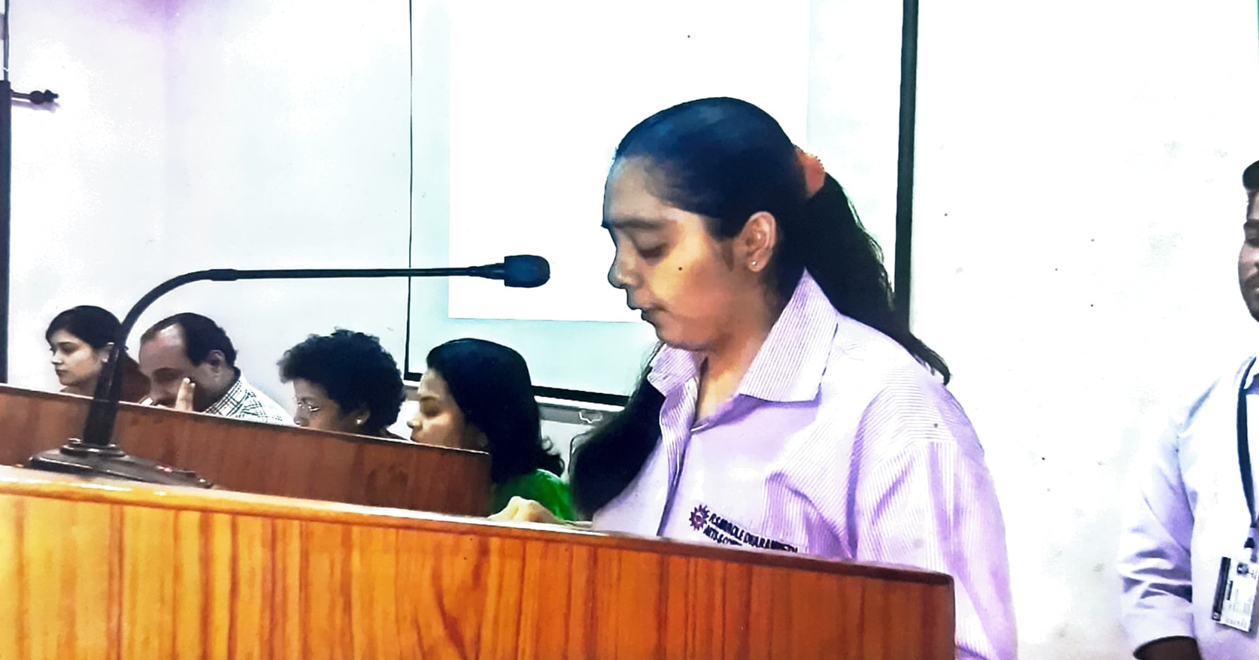

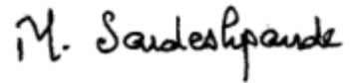
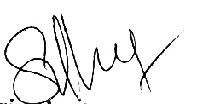
Dr. Sandhya Nair Dr. Manjushree Sardeshpande
Principal Convener

