Intercollegiate
Mehandi 2018-19

Dharampeth Education Society’s

NORTH AMBAZARI ROAD, NAGPUR – 440 010, Dial: 0712- 2557612
(Established in 1960)
Accredited Grade “A” by NAAC
URL: www.rsmdacc.edu.in Email :principalrsmcsn@hotmail.com
Dr. Sandhya Nair
Principal

Date: 22/01/2019
NOTICE
It is hereby informed that our college is going to organize Inter Collegiate Mehandi Competition on 29 January 2019 at 09.00 am. Interested students are required to give your name to Prof. DrAshwini Meshram, Prof. Jaya Munghate , Prof. Shivani Degvekar on and before 25 January 2019 and all the students are required to attend the program.

MEHENDI
Inter – Collegiate Mehendi Competition
- Date : 29 January 2019 Time : 9 a.m. to 10 a.m.
- Venue of Event & Registration: RSMDACC, SantGadgebabaMaharaj Hall, Old Building Second floor
- Max number of participants – 02 from each college.
- Cash Prizes :
First Prize : 500/- Second Prize : 300/ Third Prize : 200/-
- Rules :
- The participants should bring the required material and his / her Mehendi partner.
- The participants have to get themselves registered at the registration counter and draw the Mehendi on their allotted number.
- Contact Persons: DrAshwini Meshram-9422843916, Prof. Jaya Munghate 8421070986 Prof. ShivaniDegvekar 9881614903

Report on Intercollegiate
Mehandi 2018-19

R. S. Mundle Dharampeth Arts and Commerce College is always striving hard to enhance hidden talent through various activities at its campus. Irrespective of the exposure and experience, they adorned their hands with mendhi designs which helped them boost their confidence in the art. Principal of the school, encouraged the students and the department for putting in efforts to keep this cultural and traditional art form alive.

As one more step, college had organized Intercollegiate Mehandi Competition on 29 January 2019 at R. S. Mundle Dharampeth Arts and Commerce College old building 2nd Floor Gadge Baba Hall. 33 Students from 11 Colleges participated in the competition enthusiastically. Miss. Khushi Kamble handled the responsibility of the examiner.

- Dr. Ashwini Meshram, Prof. Jaya Munghate , Prof. Shivani Degvekar worked hard for the success of the event.

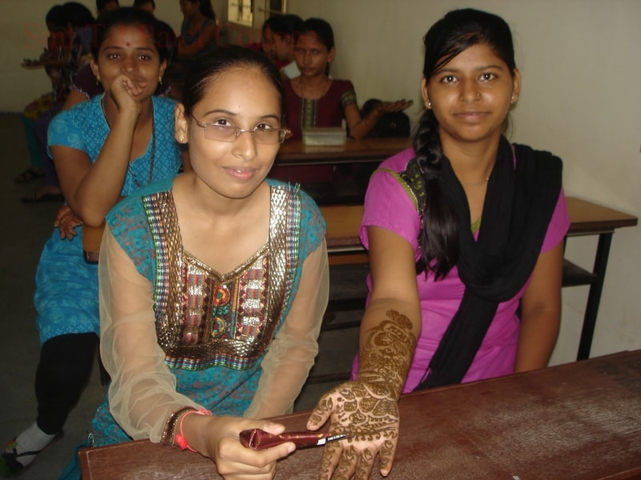
Name of Event | No of Participants from the college | No of Participants from other college | No of students attended | No of other colleges | Winner
Mehandi | 9 | 24 | 33 | 11 | 1’st Prize- Nikita Sonule (LAD College)  2’nd Prize- Vidya Patel (G.S. College)

